Bob’s
Travel Club
2019 trips
Annual Membership Fee £5.00 Payable in January each year
JANUARY – MON 28th – LUNCH AT THE NESS at SHALDON - £8pp Travel only
The summer home of the Clifford family built in 1810…now a stunning pub on the Teign estuary shoreline. Food needs to be Pre ordered. You can view menu at www.theness.co.uk or Tel 01312 125933. Please call and order
FEBRUARY – MON 25th IKEA EXETER - £12pp
IKEA is a Swedish-founded multinational group that designs and sells ready-to-assemble furniture, kitchen appliances and home accessories, among other useful goods. Its worth the trip just for their Swedish meat balls! You can view their menu here https://www.ikea.com/gb/en/store/exeter/restaurant-exeter/ Full disabled access. Café
MARCH – FRI 29th – LANYHDROCK HOUSE - £26.50pp inc entry ( NT members £15)
Lanhydrock, near Bodmin Cornwall, is a magnificent late Victorian country house with extensive servants’ quarters, gardens and a wooded estate. Cafe/restaurant. Most of house accessible for disabled persons but not the garden Contact details lanhydrock@nationaltrust.org Tel: 0208265950
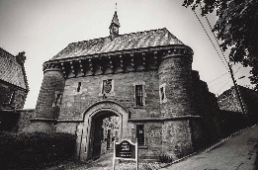
APRIL - THUR 18th BODMIN JAIL and COURTROOM EXPERIENCE - £26pp inc entry
A courtroom experience at the shire Hall in Bodmin and a visit to the holding cells then on to discover life behind bars as an 18th century prisoner in the heart of Cornwall. Bodmin Jail was originally built for King George III in 1779. Café. Some level access but stone steps and uneven ground http://www.bodminjail.org/ 01208 76292
MAY – FRI 3rd TOBY BUCKLAND FLOWER SHOW @ Powderham castle - £18pp inc entry
Held in the stunning riverside location of Powderham Castle, near Exeter in Devon, the festival promises a bounty of blooms, guaranteed to get your garden off to a flower-filled start. Toby Neale Buckland is an English gardener, best known for being the main presenter in BBC's long running flagship gardening programme Gardeners' World. Celebrity speakers/food. Access good some uneven ground. https://tobygardenfest.co.uk/
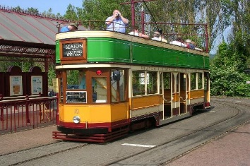
MAY – THUR 30th SEATON TRAMWAY/DONKEY SANCTUARY inc fare lunch & cream tea £35.50pp
A fabulous trip on Seaton tramway https://www.tram.co.uk/ a truly English folly to Colyton where you will enjoy lunch at the Tramstop Café, then back on the bus to the Donkey Sanctuary for the afternoon including a delicious cream tea, talk and guided tour about the amazing work of the sanctuary. https://www.thedonkeysanctuary.org.uk/ Access good

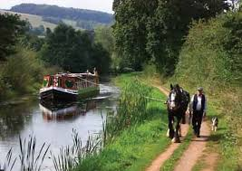
JUNE – WED 12th TIVERTON CANAL & TIVERTON MUSEUM inc entry £26.50
Enjoy a relaxing trip along the canal on the last horse drawn barge in Britain https://www.tivertoncanal.co.uk/ for 1.5hrs then off to Tiverton for lunch at the Madhatters Café (not inc in cost) and a visit to Tiverton museum to explore their fascinating collection about mid Devon life. Access good. http://www.tivertonmuseum.org.uk/
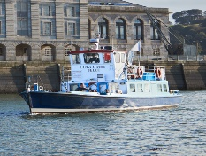
JUNE – MON 24th PLYMOUTH CRUISE TO CREMYL & MOUNT EDGCOMBE £20.50 inc entry
One hour harbour cruise with stop off service at Cremyll Quay in Cornwall. Visit the beautiful village of Cremyll and stroll around historic Mount Edgcumbe house and Country Park, the former home of the Earls of Mount Edgcumbe. http://www.mountedgcumbe.gov.uk/ level access (buggy available) Café
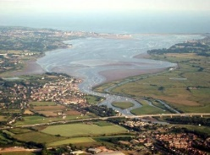
JULY – FRI 26th STUART LINES BOAT TRIP UP THE RIVER EXE - £21pp inc boat trip
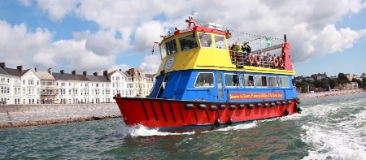
2.5 hr boat trip from Exmouth up the Exe to Exeter Quay. Includes commentary on the wonders and wildlife of the river Exe. The bus will drop you at the boat and collect you from Exeter Quay. Level access on to the boat. A favourite last year !
AUG – MON 12th GREENWAY £19.50 inc entry (NT members £10)
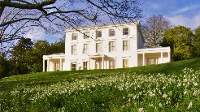
The holiday home of the famous and much-loved author Agatha Christie and her family. Café . Buggy from car park to house if required, some of grounds accessible. https://www.nationaltrust.org.uk/greenway Tel 01803 842382
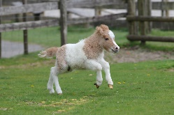
SEPTEMBER - FRI 20th MINITURE PONY CENTRE DARTMOOR Inc entry £16.50
A Magical Dartmoor Day.....an idyllic setting in the heart of scenic Dartmoor. A hidden gem of all things cute and cuddly! Our visit will include a talk about the work done at the centre. Café with views. Good access http://www.miniatureponycentre.com/ Tel 01647 432400
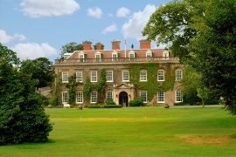
OCT - THUR 17th BIRDS OF PREY FERMOYS & BRADLEY HOUSE inc entry £20
An experience with beautiful birds of prey, included is a photo opportunity handling the birds and a talk from the expert. Great Café at Fermoy’s for lunch (not inc in price) then on for a visit Bradley House a medieval house surrounded by meadows and woodland https://www.nationaltrust.org.uk/bradley No toilet
NOV – MON 18th EXETER CHRISTMAS MARKET - £10pp
A chance to buy those festive goodies!
DEC – FRI 13th THE EDEN PROJECT LIGHT & SOUND FESTIVAL - £25pp inc entry TBC
Multiple laser systems will interact in amazing ways with natural phenomena such as rain, mist, plants, trees and people - as well as nature inspired architectural forms to create an unforgettable visual feast. PLEASE NOTE: This has not yet been confirmed for 2019 and will be an evening trip
YOUR SEAT IS NOT BOOKED UNTIL PAYMENT IS RECEIVED (cancellation fee £10) BACS: Santander, Totnes, 58/60 Fore Street, Totnes, Devon, TQ9 5RU S/C: 09-01-52 Acc No: 98909901 CHEQUES: Totnes and Rural Community Transport Send to: 14 Follaton Plymouth Rd Totnes TQ9 5NB E Mail: bobthebus@yahoo.com Tel: 07800745332 between 10am and 3pm
NOTE – Please make your own inquires on access or specific needs before booking

